**INDEX**

|  |  |  |
| --- | --- | --- |
| **SR NO.** | **TOPIC NAME** | **PAGE NO** |
| **1.**  **1.1**  **1.2**  **1.3**  **1.4** | **PROJECT DEFINATION,SCOPE AND OBJECTIVES**  **PROJECT PROFILE**  **PROJECT DEFINATION**  **GOALS AND OBJECTIVES**  **SCOPE** | **1**  1  1  2  3 |
| **2.**  **2.1**  **2.2**  **2.3**  **2.3.1**  **2.3.2**  **2.3.3** | **SYSTEM REQUIREMENT STUDY**  **USER CHARACTERISTICS**  **SOFTWARE AND HARDWARE REQUIRMENT**  **CONSTRAINTS**  **USER INTERFACE**  **COMMUNICATION INTERFACE**  **SOFTWARE INTERFACE** | **4**  4  5  6  6  6  6 |
| **3.**  **3.1**  **3.2**  **3.3**  **3.4**  **3.5**  **3.5.1**  **3.6**  **3.6.1**  **3.6.2**  **3.6.3**  **3.6.4**  **3.6.5**  **3.7**  **3.7.1**  **3.7.2**  **3.7.3**  **3.7.4**  **3.7.5** | **SYSTEM ANALYSIS**  **STUDY OF THE CURRENT SYSTEM**  **PROBLEM AND WEAKNESS OF CURRENT SYSTEM**  **REQUIREMENT OF NEW SYSTEM**  **FEASIBILITY STDY**  **FUNCTION OF SYSREM**  **USECASE DIAGRAM**  **DATA MODELING**  **CLASS DIAGRAM**  **OBJECT DIAGRAM**  **SEQUENCE DIAGRAM**  **DATA DICTIONARY**  **E-R DIAGRAM**  **FUNCTIONAL AND BEHAVIARAL MODELING**  **CONTENT DIAGRAM**  **DATA FLOW DIAGRAM**  **CONTROL FLOW DIAGRAM**  **STATE DIAGRAM**  **ACTIVITY DIAGRAM** | **7**  7  7  7  8  9  9  10  10  11  12  13  16  17  17  18  21  22  23 |
| **4.**  **4.1**  **4.2**  **4.3**  **4.4**  **4.5**  **4.6**  **4.7**  **4.8**  **4.9**  **4.10**  **4.11** | **SNAPSHOTS**  **HOME PAGE**  **EMPLOYEE REGISTRATION PAGE**  **EMPLOYER REGISTRATION PAGE**  **CONTACT PAGE**  **POST JOB PAGE**  **MANAGE JOB PAGE**  **DOWNLOAD THE RESUME PAGE**  **JOB DEATIALS PAGE**  **ADD/DELETE CATEGORIES PAGE**  **CONTACT PAGE**  **VARIFY PAGE** | **24**  24  25  26  27  28  29  30  31  32  33 |
| **5.**  **5.1** | **ARCHITECTURE OF NEW SYSTEM**  **PACKAGE DIAGRAM** | **34**  34 |
| **6** | **CONCLUSION** | **35** |
| **7** | **BIBLIOGRAPHY AND REFERENCE** | **36** |

**JOB PORTAL**



**Date:**

**ABSTRACT**

In the current scenario, there is a rat race in each and every professional field. It is true for the job market too. A job portal is a website dedicated for online information about recruiters as well as job seekers.

A job portal helps both the job seekers and recruiters finding the right organization or the employees. In the case of job seekers, according to their educational qualification, experience and their preferences, the job portal shows the list of companies to the job seeker. And, to the recruiters, provides the suitable candidtes from a pool of lakhs.

So, a job portal is the perfect online arena, where both the job seekers and the recruiters find their goal in the pursuit of getting a top notch company or the suitable candidates

Career Info Application was developed for creating an interactive job vacancy form for candidates. This web application is to be conceived in its current form as a dynamic site-requiring constant updates both from the seekers as well as the companies.  
An employer being registered in the web site has the facility to buy the services. Being an authorized user he can publish vacancy details, either of IT or Functional, of the organization.  
A Job Seeker being registered in the web site has the provision to fill up the Curriculum Vitae and in further he/she could update the resume.   
Based on the candidateâ„¢s profile the Career Info segregates candidates and post their resume to the corresponding companies. The candidates are intimated, with, the list of companies they are listed in, in their respective home page. The company has the provision of receiving candidates resumes.  
A user is checked for authentication by username and password.  
The database is perfectly designed sticking to the rules Data Consistency, Data Dependency, Non Redundancy, and Data Integrity.  
Career Info Application was developed for creating an interactive job vacancy form for candidates. This web application is to be conceived in its current form as a dynamic site-requiring constant updates both from the seekers as well as the companies. On the whole the objective of the project is to enable jobseekers to place their resumes and companies to publish their vacancies. It enables jobseekers to post their resume, search for jobs, view personal job listings. It will provide various companies to place their vacancy profile on the site and also have an option to search candidate resumes. Apart from this there will be an admin module for the administrator to make changes to the database content.

**ABOUT THE PROJECT**  
Career Info is a consultancy where the candidates come and post their resume for their career. Such consultancies help the candidates in getting a good job in their future. Career Info have their offices worldwide in order to have a good influence with their clients located abroad. They charge for their services when a company becomes a registered user.  
It is considered as one of the efficient way to recruit employees because some of candidates may not be aware of the present companies and their global existence. CareerInfo.com has their own software development division where the data are manipulated and stored efficiently. Many MNCâ„¢s are the clients of Engagement staffing.com.   
Motto:  
The companyâ„¢s Motto is to serve things in a better way for a right person.  
  
  
**ACTIVITIES UNDERTAKEN**  
  
Candidate registration:  
This dot com company stores all the details of the candidates who have filled up their candidate registration form with all their academic details, his/her experience in their related field, his/her communication address, job preference, expected salary etc in a clear format.   
Companyâ„¢s assets:  
In real terms the asset of the Career_Info.com is that their clients are located both in India and abroad. For this they need to maintain the details of their each and every client such as TCS, MYCROSOFT, WIPRO, and INFOSYS etc in a proper way. They keep track of their clients by some regular feedback regarding the vacancies going to be undertaken. It is based on agreements, facts and mutual understanding. The marketing executives of the consultancy have direct link with the HR peoples of their client that makes it easy to fill up the vacancy with a suitable person.   
  
**Resume forwarding:**  
Once their clients post their requirements then the consultancy undertakes those golden opportunities by segregating the candidates resume estimating which candidate would be more suitable for the post by going their qualification, experiences etc. For this they have to make certain assumptions.   
Prior intimation:  
Once the candidates Resume has been forwarded to their clients a prior intimation is given regarding this. In the mean while they also suggest them to adopt some interviews techniques, which are given in their web site.  
**Automatic Mailing:**   
The Main feature of this application is Automatic Mailing. Whenever jobseeker registers their resumes in this website immediately mail will be send to him, regarding the list of all job vacancies to which he/she is eligible.  
And also mail is sent to jobseeker whenever any company posts their jobs vacancies list automatically.

The project “ONLINE JOB PORTAL” is used for searching jobs in online. It is a guide and easy for individuals that the job seekers to search jobs all without expensive marketing cost. Job Portal enables you to Search Job, Search Resume, Post Job, and Post Resume etc. Here Companies can search for employees and can select them according to their needs.  
There are mainly 3 modules in Job Portal. The modules are

**1. Admin Module  
2. Job Seeker Module.  
3. Companies Module.**

Admin has all the power like add a company or a job seeker, delete a company or job seeker etc. Job seeker module includes register a job seeker, Build his resume, update resume, search for job etc. Company module includes register a company, register their requirements, update it and search for employees

**Introduction :-**

This document provides details about the entire software requirements specification for the online job portal. The project Online Job portalis aimed at developing a web-based and central Recruitment Process System for the HR Group of a company.

**Purpose :-**

This system tends to replace the existing manual system for the recruitment process which is a time consuming, less interactive and highly expensive. The main features of this system will be creating vacancies, storing Applicants data, Interview process initiation, Scheduling Interviews, Storing Interview results for the applicant and finally Hiring of the applicant. Reports may be required to be generated for the use of HR group.

# System Description : -

The name of the project is Online Job portal

The website provides both the jobseekeers and the recruiters his PIN number which is unique.

The main stakeholders of this system are:

1. Recruiting manager.

2. Vacancies

3. Job Seekers.

4. Administrator

This system enables the Recruiting manager to login to the system and create a vacancy and post it on the web. The Recruiting manager can associate jobseekers with a vacancy and Schedule the interview. He is able to search on jobseeker number and Vacancy number.

This system enables the jobseekers to login, to view all the vacancies and to view the applicant and vacancy details. He is also able to search on interview date, number and vacancy number.

The Job Seekers can register and create a profile. He/She can search and apply for jobs online. He could view his interview details and application status.

## Scope

It provides the Recruiting people with all the necessary tools to schedule the interview and applicants to register and apply for jobs and interviewers to view the interview details.

It provides the users with all the necessary privileges to access and modify

The data intended for them.

It doesn’t entirely replace the existing system but it mostly automizes the

Recruitment process and all the data used.

## Success Criteria

This system automates the manual recruitment process. We believe that once the organization chooses to use this system, it will eventually recognize the value and necessity of this system and understand the problems involved in the manual process.

# Constraints:

**Technical Constraints**

PHP 5.0 is the front end for this application running on Windows or Linux Operating System and MySQL 5.0 is database and back end.

**Definitions ,Acronyms and Abbreviations :-**

1. Recruiting manager : The person who creates vacancies(HR Manager).
2. Job Seekers. : The person who sell applies for job
3. Number : The unique id given to either seeker,Administrator or Recruiter who access the data in the site

**Project Overview :-**

**The requirements are as follows:   
1.Generic:**  
a. Login to the system through the first page of the application – the welcome message should display the Name and Employee number of the person.  
b. Change the password after login to the application (optional)  
c. See his/her details and change it.(Optional)  
d. Help from the system  
 **2.Recruiter group:**  
a. Should be able to create a new vacancy.  
b. Should be able to change any of the editable details for the vacancy.  
c. Should be able to search on Applicant Number and Vacancy Number.

**3. Administrator**

a. Should be able to create a new applicant.  
b. Should be able to change any of the editable details for the applicant.  
c. Should be able to search on Applicant Number and Vacancy Number.  
d. Attach an applicant to a vacancy - The relationship between applicant and vacancy.  
  
**3. Job Seeker:**   
a. Should be able to view all vacancies scheduled to be taken.  
b. Should be able to view the details of the company.  
c. Should be able to view the details of the vacancy.  
d. Should be able to search on vacancies, Applicant Number and Vacancy Number.   
 **4. Other details:**  
a. The vacancy should have the following details:  
i. System should generate a Vacancy number sequentially. This should be unique and cannot be changed later on.  
ii. Date of the creation of the vacancy should default as today – This cannot be changed later on.  
iii. Status of the Vacancy – Open/Close/Suspended. This should default as Open but can be changed later by HR.  
iv. Title of the Vacancy (like PHP Developer)  
v. Detailed description about the vacancy  
vi. Number of job opening under that vacancy (like 5 numbers of PHPDevelopers required)..  
vii. Department in the company – this should come from a drop-down box which have the Department list.  
viii. Date by which the vacancy should be fulfilled/gets closed – this can be left blank otherwise the vacancy will close on that day by default.  
ix. List of all the seekers already ‘Selected’ for a job openings in the vacancy.

**Overview :-**

This project is aimed at developing a web-based and central Online job portal for the HR Group for a company. Some features of this system will be creating vacancies, storing Applicants data, Interview process initiation, Scheduling Interviews, Storing Interview results for the applicant and finally Hiring of the applicant. Reports may be required to be generated for the use of HR group.

**Product perspective :-**

This software is totally self contained and works relatively as efficient as other packages related to the subject. It provides simple database rather than complex ones for high requirements and it provides good and easy graphical user interface to both new ,naïve as well as experienced users of the computers

**Brief description of these component**

* **HTML:**  
  **HTML**, which stands for **HyperText Markup Language**, is the predominant markup language for web pages HTML is the basic building-blocks of webpages.
* **JavaScript:**  
  **JavaScript**, also known as ECMA Script is a prototype-based object oriented scripting language that is dynamic, weakly typed and has first class functions. It is also considered a functional programming language like scheme and OCaml because it has closures and supports higher order functions.
* **CSS:**  
  **Cascading Style Sheets** (**CSS**) is a style sheet language used to describe the presentation semantics (the look and formatting) of a document written in a markup language.
* **PHP:**  
  **PHP** is a general-purpose scripting language originally designed for web development to produce dynamic web pages.
* **MySql**  
  MySql is a relational database management system (RDBMS) that runs as a server providing multi-user access to a number of databases.
* **Wamp server 2.0(for winows platform)**Wamp server is free to use for all the developers, Wamp server runs on only windows based platform, if we used different OS then we have to used different version of Wamp i.e(lamp for linux, mamp for mac os), xamp is common PHP based development tools for all perating system.
* **Filezilla**

It is a FTP(File transfer Protocol) used to upload the file/project to host site. It is ensure to upload a project to the host server through filezilla and it is very fast to upload the file.

BACK END OF THE PROJECT

Window os:-

Window Operating system used as interface

Mysql:

Mysql Used for database managemen

Server:

Apache 2.0,Wamp

**NECCESSARY TO SOFTWARE AND HARDWARE**

**Software**

Software, commonly known as programs, consists of all the electronic instructions that tell the hardware how to perform a task. These instructions come from a software developer in the form that will be accepted by the operating system that they are based on. For example, a program that is designed for the Windows operating system will only work for that operating system. Compatibility of software will vary as the design of the software and the operating system differ. Software that is designed for Windows XP may experience compatibility issue when running under Windows 7.

Software can also be described as a collection of routines, rules and symbolic languages that direct the functioning of the hardware. Software is capable of performing specific tasks, as opposed to hardware which only perform mechanical tasks that they are mechanically designed for. Practical computer systems divide software systems into three major classes:

* **System software**: Helps run computer hardware and computer system. Computer software includes operating systems, device drivers, diagnostic tools and more.
* **Programming software**: Software that assists a programmer in writing computer programs.
* **Application software**: Allows users to accomplish one or more tasks.

**Software Requirements**

**Development Platform**

Server : Apache 2.0,Wamp

Front End : Core PHP

Data Base : MYSQL

**Working Platform**

Operating System : Microsoft Windows 2000 and more

Data Base : MYSQL

**Hardware**

Hardware refers to the physical elements of a computer. Also referred to as the machinery or the equipment of the computer. Examples of hardware in a computer are the keyboard, the monitor, the mouse and the processing unit However, most of a computer's hardware cannot be seen; in other words, it is not an external element of the computer, but rather an internal one, surrounded by the computer's casing. A computer's hardware is comprised of many different parts, but perhaps the most important of these is the motherboard. The motherboard is made up of even more parts that power and control the computer.

In contrast to software, hardware is a physical entity, while software is a non-physical entity. Hardware and software are interconnected, without software; the hardware of a computer would have no function. However, without the creation of hardware to perform tasks directed by software via the central processing unit (box), software would be useless. Hardware, in the computer world, refers to the physical components that make up a computer system. There are many different kinds of hardware that can be installed inside, and connected to the outside, of a computer. Some of common hardware that find inside a computer are Motherboard, Central Processing Unit (CPU), Random Access Memory (RAM), Power Supply, Video Card, Hard Drive, Optical Drive (i.e. BD/DVD/CD drive), Sound Card, Network Interface Card (NIC), Analog Modem, FireWire/USB Expansion Card, etc. Some of common hardware that might find connected to the outside of a computer is Keyboard, Mouse, Printer, Scanner, Speakers, Monitor, etc. The following hardware is referred to as network hardware and various pieces are often part of a home or business network such as Router, Network Switch, Access Point, Repeater, Bridge, Print Server, Firewall, etc

**1.PROJECT DEFINATION , SCOPE AND OBJECTIV**

**1.1 PROJECT PROFILE**

* **Project Title** : Online job portal
* **Objective :** To develop a user-friendly & efficient system
* **Operating System :** Microsoft Windows 7
* **Back End :** SQL Server, apachi
* **Front End Used :** PHP
* **Project Guide :**
* **Submitted By :**
* **Submitted To :**

**1.2 PROJECT DEFINATION**

Internet has made this world smaller now. The world environment is becoming competitive. Every person nowadays wants to reach at the heights. Especially when education is growing among the people, the need for job comes first. Even there are so many big firms who need so many experts.

So many people are recruited and given chance to show their talents. For that, sometimes, job openings are created on websites. The advertisements are given in newspapers. Also campus interviews are held for recruiting freshers. Some exams taken and then interviews are held, which filters the people and selects the candidates.

For giving flexibility to this recruitment process, this project has been developed. This project contains both modules – Client side module (to apply for job online) as well as Admin side module (for creating job vacancies and to manage the applied candidates). Let’s see more detailed information about the project in following sections.

## 1.3 GOALS AND OBJECTIVES

The purpose of this project is to develop the user friendly and interactive website which will allow the candidate to apply for the job vacancy available in the company. The person will be able to see the vacancies if present. He can apply for any number of jobs he wishes to apply. He will be able to register for that and will be notified for which jobs from his selected jobs, he is eligible.

The main purpose of this project is about giving flexibility to the Company’s Recruitment Managers as this website plays main role at admin side. The project contains layers for different users at admin part so there is no chance of disturbing any of the process as the sub-admin (lower level admin) will not be given rights to make any changes in the functionality. Even given, the sub-admin will be only able to send requests to higher level admin for any changes like posting job vacancies etc.

The company will be able to post these vacancies on internet in his own website so there is no need to advertise for his company’s vacancy at any other place except his own site. Any user will be able to open the company’s site and see the vacancies in the company

**1.4 JOB PORTAL**

The aim of the project is to build a simple, effective computerized Recruitment Module, which complements the regular workflow of HR management. It starts from the process of collecting relevant details and requirements from the Users until the candidate becomes a successful employee in the company. It covers the traditional HR functions:

1. Define Recruitment Processes
2. Smoothen the process of recruitment replacing the traditional method of recruitment.
3. Collect and Manage applicants’ profile, including personal detail, education details and work experience (if any).
4. Convert successful Applicants to Employees.
5. Manage the Recruitment Process for each Position through tracking all steps.
6. Enable Users to view the website for various jobs posted on the system
7. Allow Registered Users to add their profile and appear for the evaluation process
8. Provide useful analysis; in the form of Reports and Statistics to support decision-making.
9. Filter worthy candidates based on the company’s requisite

**Proposed Project: Job Portal**

A job portal helps both the job seekers and recruiters finding the right organization or the employees. In the case of job seekers, according to their educational qualification, experience and their preferences, the job portal shows the list of companies to the job seeker. And, to the recruiters, provides the suitable candidtes from a pool of lakhs.

So, a job portal is the perfect online arena, where both the job seekers and the recruiters find their goal in the pursuit of getting a top notch company or the suitable candidates.

**Present scenario:**

Applying for a job online or search for a potential candidate has become the order of the day. Earlier the job posting was limited to newspapers. However, at present, millions of people are using job portals to bag their dream job or hire a suitable applicant. While the job aspirant get hold of the most lucrative job opportunities, the employers make sure that they got the best possible individual with the help of these jobs sites, employment sites, or job centre. As the trend of online recruitment is getting popular day by day, each individual is compelled to try their luck in the employment sites. Job portal plays a very vital role in the job market and function as a bridge between recruiters and job seekers. Software, IT, management, pharmacy and finance companies were the sole users of job portals earlier; however, as time progresses, people from all other sectors started posting jobs on such portals. There are certain things, which make Job Portals an ideal place for complete hiring and recruiting process. Recruiters can hire employees as per their requirements.

**Competition:**

As you are well aware, there are countless job portals available online. It should be worth to create a job portal, which would save time, reduce costs, and also assist in searching the right candidate as well as getting the right possible job, especially in a highly competitive job market. Effective methods and technologies only can make the recruitment process easy.

**Sources of revenue:**

1. Revenue from recruiting companies for publishing their job related advertisements
2. Substantial revenue from the job seekers for creating a premium account, which helps in advanced job searches
3. Online advertisement

**System:**

**1. Designing and Implementing Job Seekers & Job Providers:**

The aim of this module is to collect data from the user; he may a job seeker or a job provider. Both of them are potential clients to our Resume Art. A user should be registered regardless of whether he is a job seeker or a provider. In this module we register the user and grab as many details as possible about the user.

**2. Designing and implementing Resume Database, job database**

The aim of the module is to create a resume for all his job seekers asking the details about the experience, education, skills, affiliations and references for the project.

1. **Designing a Recruitment System**

The aim of the module is to design a dynamic search engine for the Resume art data base which can provide data for the job seekers and job providers.

**2.2 SOFTWARE AND HARDWARE REQUIREMENT**

* **Software Environment:**

|  |  |  |  |
| --- | --- | --- | --- |
| **Tools/Technology** | **Front-end** | **-** | PHP |
| **Back-end** | **-** | MySQL |
| **Browser** | **-** | Internet Explorer 6.0, Netscape Navigator, Firefox, Google Chrome |
|  | **Editor** | **-** | Notepad++ |
| **Operating System** | Windows 98 to Windows 2003 &Windows XP. | | |

* **Hardware Environment:**

|  |
| --- |
| **Client Configuration** |
| * Pentium IV, 750 MHz, 20GB HDD * Operating System : Windows XP/2000 * RAM : 512 MB minimum * 400MB Minimum Free Space on Drive * Microsoft Office |
| **Server Configuration** |
| Servers, each with following configuration   * CPU * Operating System: Windows XP * RAM : 1GB Minimum * 40GB Minimum Free Space on Drive * 750MHz |

**Advantages:**

* User friendly registration System
* Search jobs by keywords, field and location
* Easy to edit and update resume
* Free Resume hosting
* Wide range of resume formats
* resume builder
* Search for a particular candidate by skills

**Modules of project:**

The project can be divided in to four main modules.

• Registration module

• Job Seeker Administration section

• Job Provider Administration section

**Module 1:**

Registration module, which is further sub-divided into:-

• Job Seeker Registration.

• Job Provider Registration.

• Change Password Job Seeker.

• Change Password Job Provider.

• Forget Password Job Seeker.

• Forget Password Job Provider.

• Login for both Job Seeker and Job Provider.

**Module 2:**

Job Seeker Administration section, which is further sub-divided into -

• Resume Registration under Vacancy Category.

• Resume Updating

• Search for Job according to his skill set.

• Expert Guidance.

• Application Status.

**Module 3:**

Job Provider Administration section, which is further sub-divided into four sub-

Sections: -

• Register Vacancy.

• Update Vacancy.

• Search for eligible candidate.

• Check Job Status

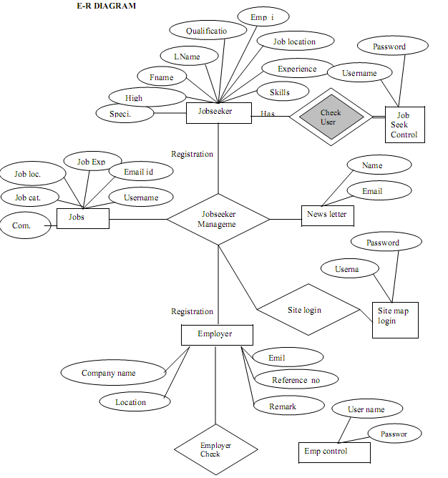

## 2.3CONSTRAINTS

**2.3.1 User Interface**

The user Interface is provided by the any kind of web browser like Internet Explorer, Mozilla Firefox, msn, safari etc. As the project is the extension of the live project, based on the client’s requirement, the project testing will be done for the above specified four browsers so the project would be portable and will have pluggable look and feel.

**2.3.2 Communication Interfaces**

This is website so it requires HTTP protocol and Internet connection.

**2.3.3 Software Interface**

The application mainly interacts with the SQL Server database for storing data at the back end. Other than this it does not deal with any software.

**3.SYSTEM ANALYSIS**

**3.1STUDY OF CURRENT SYSTEM**

The recruitment process is a very important process for all kinds of people as the common man wants the job and the company needs man power. The current system is based only on human beings. The all activities of this process are done on paper work, nothing is system dependent. The candidates apply for job manually to the company by sending their resumes. The company responds them if they are qualified and then the evaluation process takes place which filters the candidates. Filtered candidates are called for the interviews and thus the whole recruitment process takes place.

## 3.2 Problems and Weaknesses of Current System

The recruitment process is a very large and important process which is mostly done by human beings, not by the system. The conventional approach of submitting resumes to the company and then helding the evaluation process is a very tedious task as the company has to give advertisements or has to go to the colleges for recruiting people. This process can be made easy and flexible for the candidates as well as the company managers so that the whole recruitment process is handled automatically.

This conventional approach of recruiting people increases the work of maintaining candidates on paper work which requires a lot of manpower. Other than this, it increases the complexity and also contains less efficiency. The automated system needs to be found which replaces the current conventional system or at least decreases this whole process' complexity.

3.3 REQUIREMENTS OF NEW SYSTEM

The problems of the conventional recruitment process increases the need of some automated system which handles the process at some extent and can decrease the work of this process. The system can be built which is general and not specific to any company as the evaluation process contains different steps for different companies. Any company can use that system and can decrease complexity of the conventional approach. The new system may not include the phase of evaluation process but other general formalities of saving resumes and other details of the candidates, maintaining their data etc. can be included.

## 3.4 Feasibility Study

The feasibility study is the important step in any software development process. This is because it makes analysis of different aspects like cost required for developing and executing the system, the time required for each phase of the system and so on. If these important factors are not analyzed then definitely it would have impact on the organization and the development and the system would be a total failure. So for running the application and the organization successfully this step is a very important step in a software development life cycle process.

By making analysis with the requirement of the organization it would be possible to make a report of identified area of problem. By making a detailed analysis in this area a detailed document or report is prepared in this phase which has details like project plan or schedule of the project, the cost estimated for developing and executing the system, target dates for each phase of delivery of system developed and so on. This phase is the base of software development process since further steps taken in software development life cycle would be based on the analysis made on this phase and so careful analysis has to be made in this phase.

Though the feasibility study cannot be focused on a single area some of the areas or analysis made in feasibility study is given below. But all the steps given below would not be followed by all system developed. The feasibility study varies based on the system that would be developed.

* Feasibility study is made on the system being developed to analyze whether the system development process require training of personnel. This help in designing training sessions as required in later stage.
* Is the system developed has scope for expanding or scope for switching to new technology later if needed in ease. In other study is made to find the portability of the system in future.
* The above feasibilities are analysis which helps in development of the system. But the scope of feasibility study does not end with this. Analysis or feasibility study also includes the analysis of maintenance stage. In other words feasibility study is made to analyze how one would maintain the system during maintenance stage. This helps sin planning for this stage and also helps in risk analysis. Also the analysis helps in making analysis about what training must be given and how and what all documents must be prepared to help users and developers to face maintenance phase.

**3.5 FUNCTION OF SYSTEMS**

**3.5.1 USE CASE DIAGRAM**

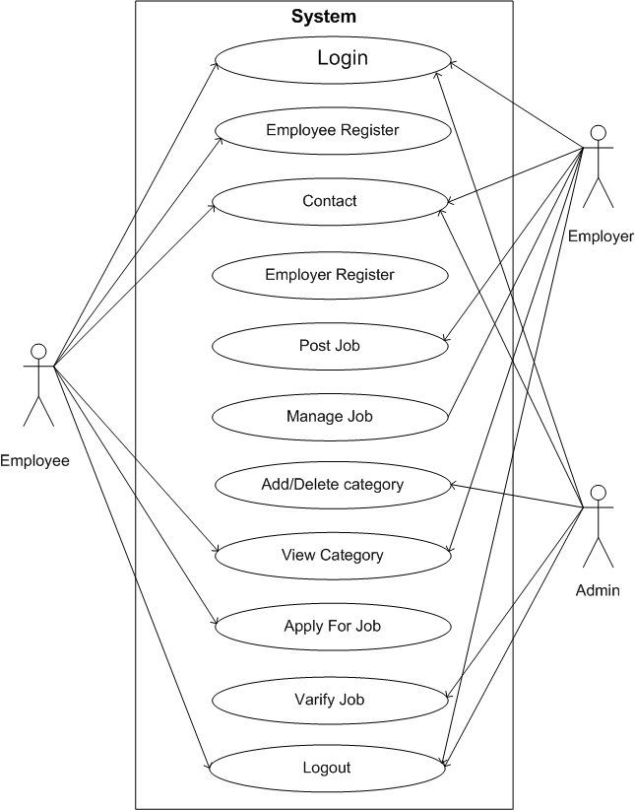

**3.6 DATA MODELLING**

**3.6.1 CLASS DIAGRAM**

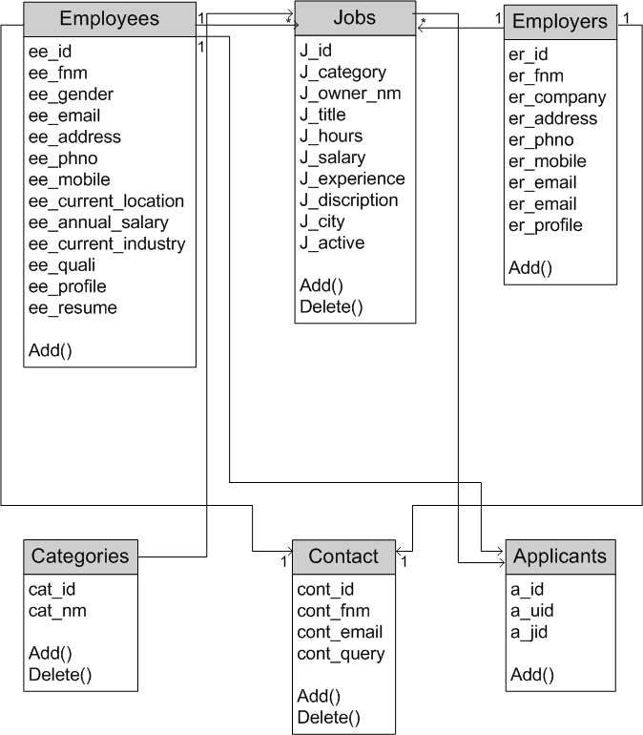

**3.6.2 OBJECT DIAGRAM**

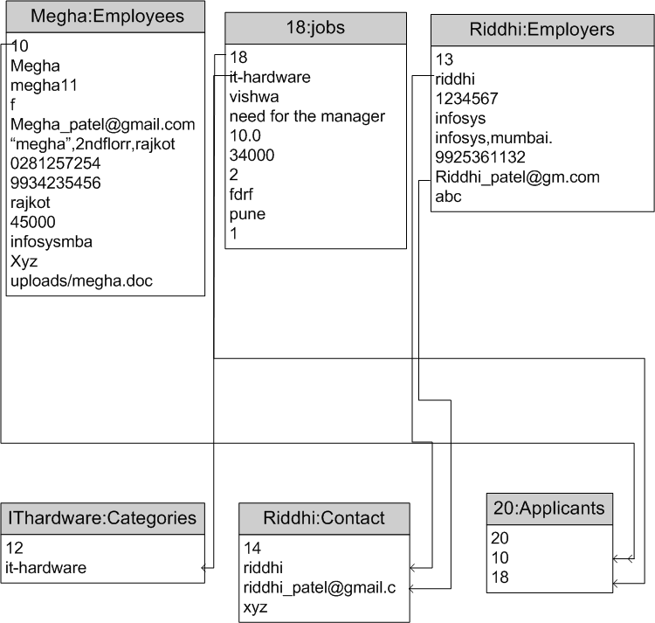

**3.6.3 SEQUENCE DIAGRAM**

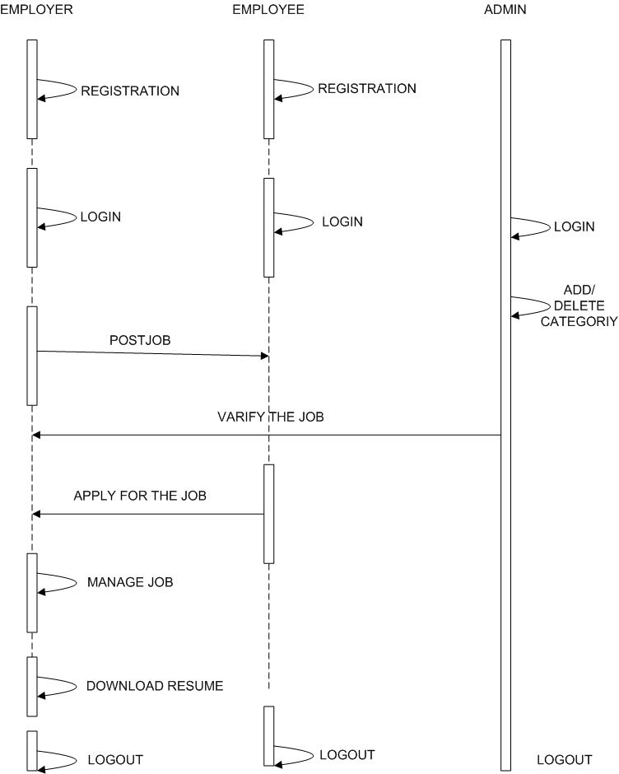

**3.6.4 DATA DICTIONARY**

**1.Admin**

|  |  |  |  |  |
| --- | --- | --- | --- | --- |
| FIELD | TYPE | NULL | EXTRA | PRIMARYKEY |
| First_name | Varchar(100) | NO | - | NO |
| Last_name | Varchar(100) | NO | - | NO |
| Admin_id | Int(100) | NO | - | NO |
| E_mail | Int(100) | NO | - | NO |
| Password | Int(100) | NO | - | NO |
| Address | Varchar(100) | NO | - | NO |
| City | Varchar(100) | NO | - | NO |
| Mobile_number | Varchar(100) | NO | - | NO |
| Pincode | Varchar(100) | NO | - | NO |

**2 EMPLOYERS TABLE**

|  |  |  |  |  |
| --- | --- | --- | --- | --- |
| FIELD | TYPE | NULL | EXTRA | PRIMARYKEY |
| Er_id | Int(4) | NO | Autoincreament | YES |
| Er_fnm | Varchar(30) | NO | - | NO |
| Er_pwd | Varchar(10) | NO | - | NO |
| Er_company | Varchar(30) | NO | - | NO |
| Er_add | Varchar(100) | NO | - | NO |
| Er_ph | Varchar(10) | NO | - | NO |
| Er_email | Varchar(30) | NO | - | NO |
| Er_company_profile | Varchar(300) | NO | - | NO |

**3.CONTACTS TABLE**

|  |  |  |  |  |
| --- | --- | --- | --- | --- |
| FIELD | TYPE | NULL | EXTRA | PRIMARYKEY |
| Cont_id | Int(4) | NO | Autoincreament | YES |
| Cont_fnm | Varchar(30) | NO | - | NO |
| Cont_email | Varchar(20) | NO | - | NO |
| cont_query | Varchar(300) | NO | - | NO |

**4.JOBS**

|  |  |  |  |  |
| --- | --- | --- | --- | --- |
| FIELD | TYPE | NULL | EXTRA | PRIMARYKEY |
| J_id | Int(4) | NO | AUTOINCREAMENT | YES |
| J_category | Varchar(40) | NO | - | NO |
| J_owner_name | Varchar(30) | NO | - | NO |
| J_title | Varchar(30) | NO | - | NO |
| J_hours | Float(3,1) | NO | - | NO |
| J_salary | Int(10) | NO | - | NO |
| J_experience | Int(3) | NO | - | NO |
| J_discription | Varchar(300) | NO | - | NO |
| J_city | Varchar(20) | NO | - | NO |
| J_active | Int(1) | NO | - | NO |

**5.APPLICANT TABLE**

|  |  |  |  |  |
| --- | --- | --- | --- | --- |
| FIELD | TYPE | NULL | EXTRA | PRIMARYKEY |
| A_id | Int(4) | NO | Autoincreament | YES |
| A_uid | Varchar(30) | NO | - | NO |
| A_jid | Varchar(30) | NO | - | NO |

**6.CATEGORIES TABLE**

|  |  |  |  |  |
| --- | --- | --- | --- | --- |
| FIELD | TYPE | NULL | EXTRA | PRIMARYKEY |
| Cat_id | Int(4) | NO | Autoincreament | YES |
| Cat_nm | Varchar(30) | NO | - | NO |

**3.6.5 E-R DIAGRAM**

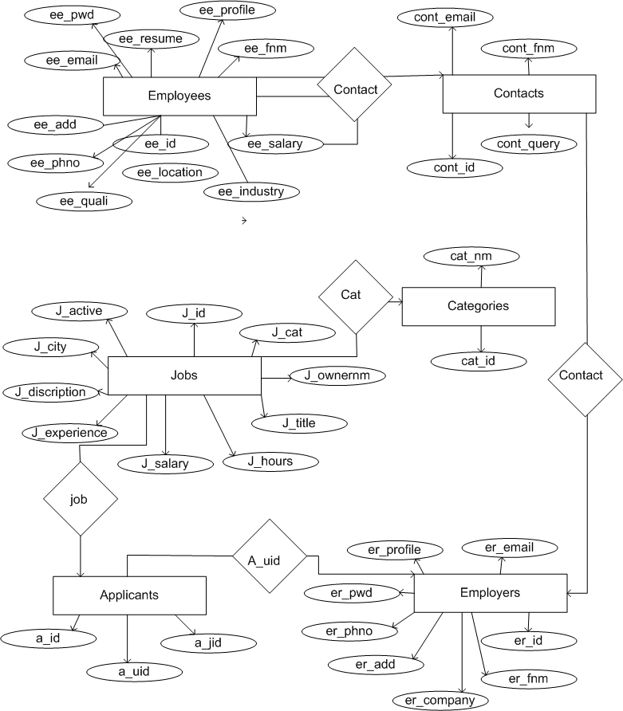

**3.7 FUNCTIONAL AND BEHAVIORAL MODELLING**

**3.7.1 CONTEXT DIAGRAM**

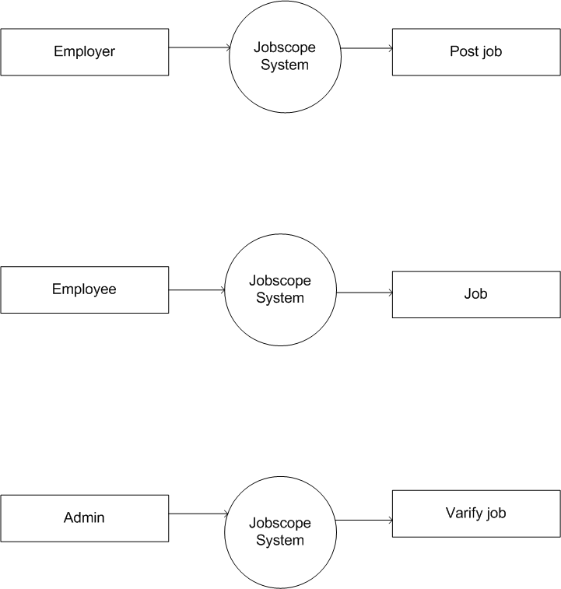

**3.7.2 DATA FLOW DIAGRAM**

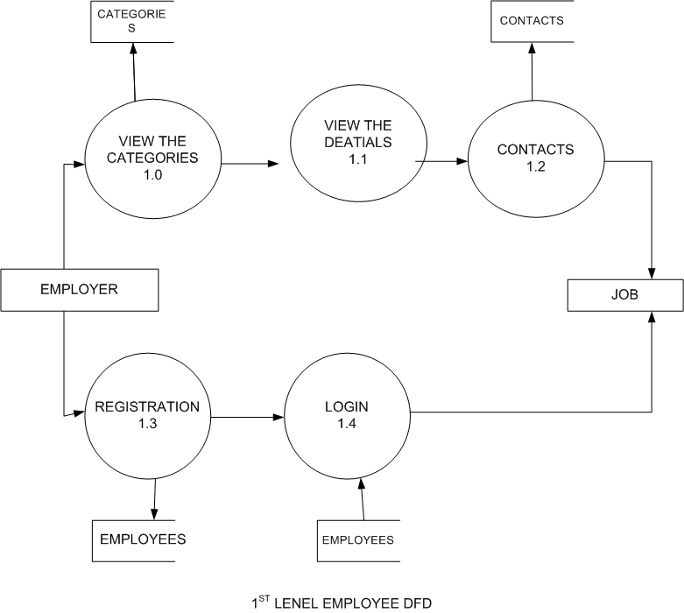

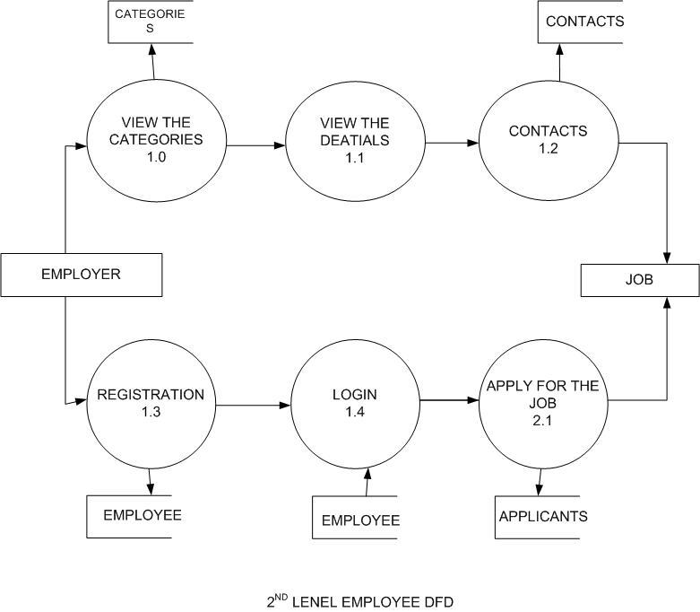

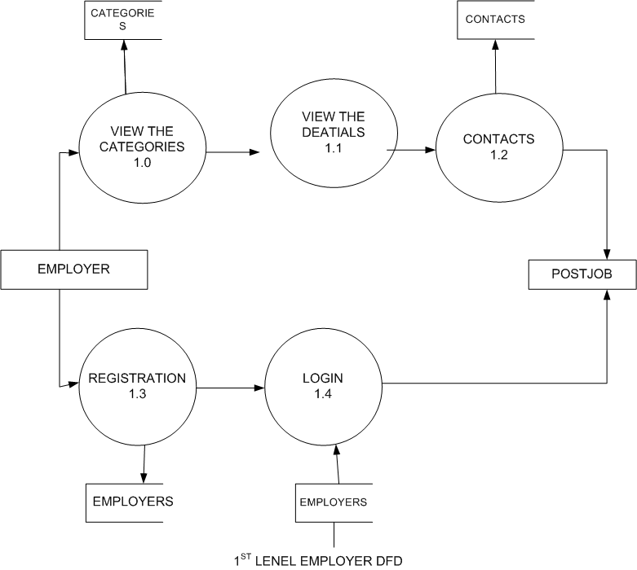

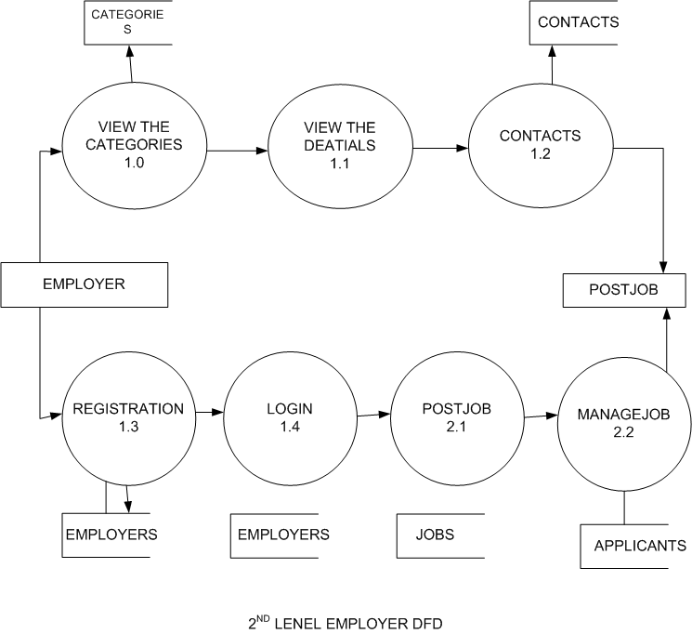

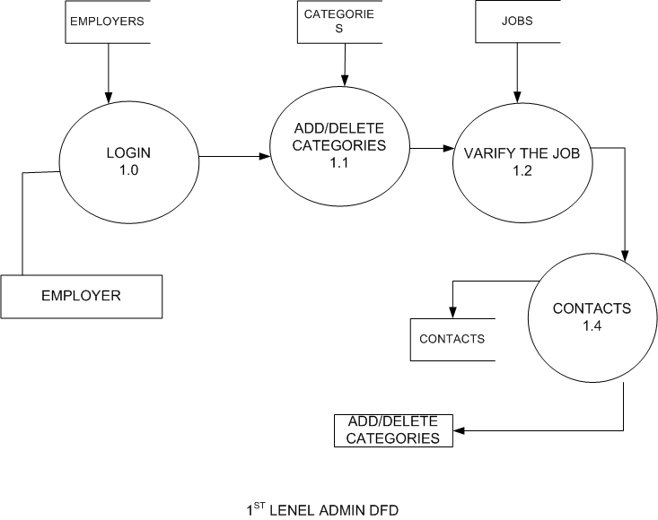

**3.7.3 CONTROL FLOW DIAGRAM**

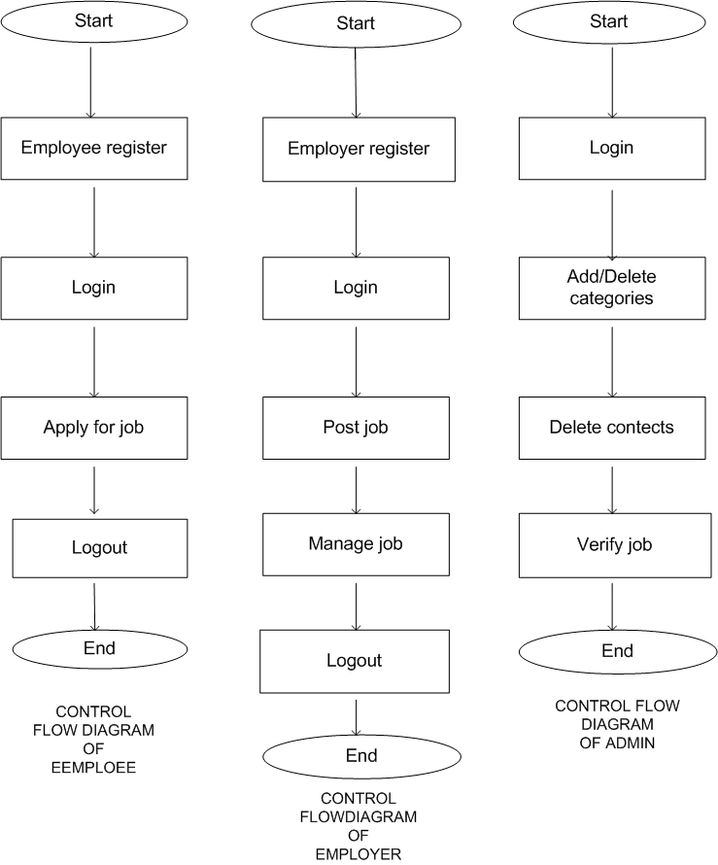

**3.7.4 STATE DIAGRAM**

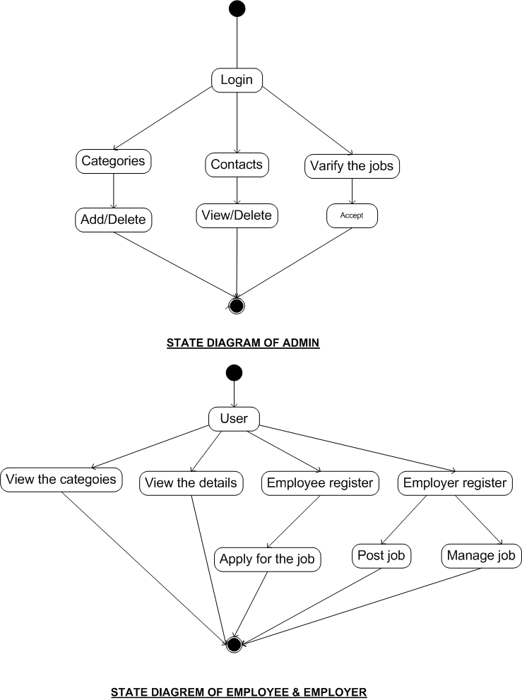

**3.7.5 ACTIVITY DIAGRAM**

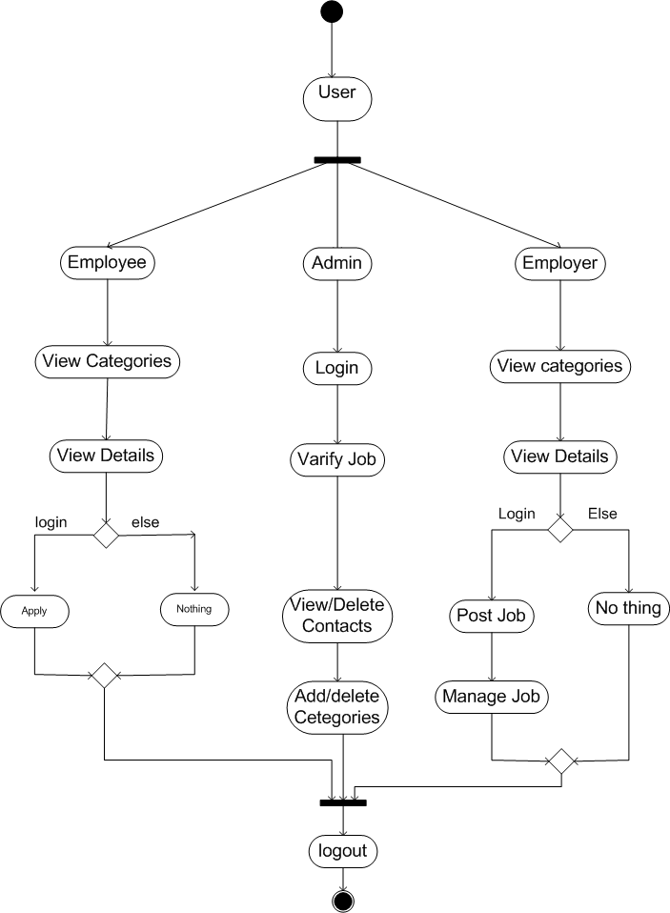

**4.SNAPSHOTS**

**4.1HOME PAGE**

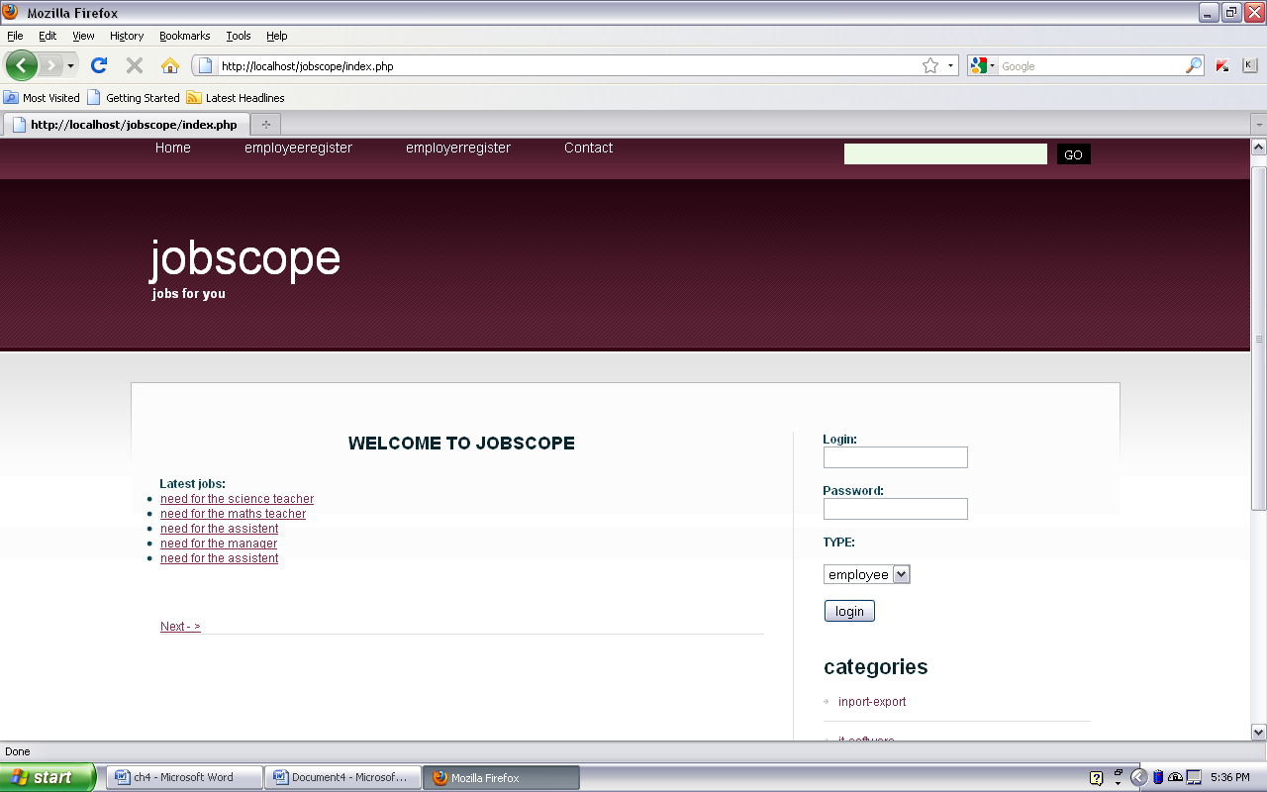

This is the home page. In this page the latest jobs are shown. This page contains login form.

**4.2 EMPLOYEE REGISTRATION PAGE**

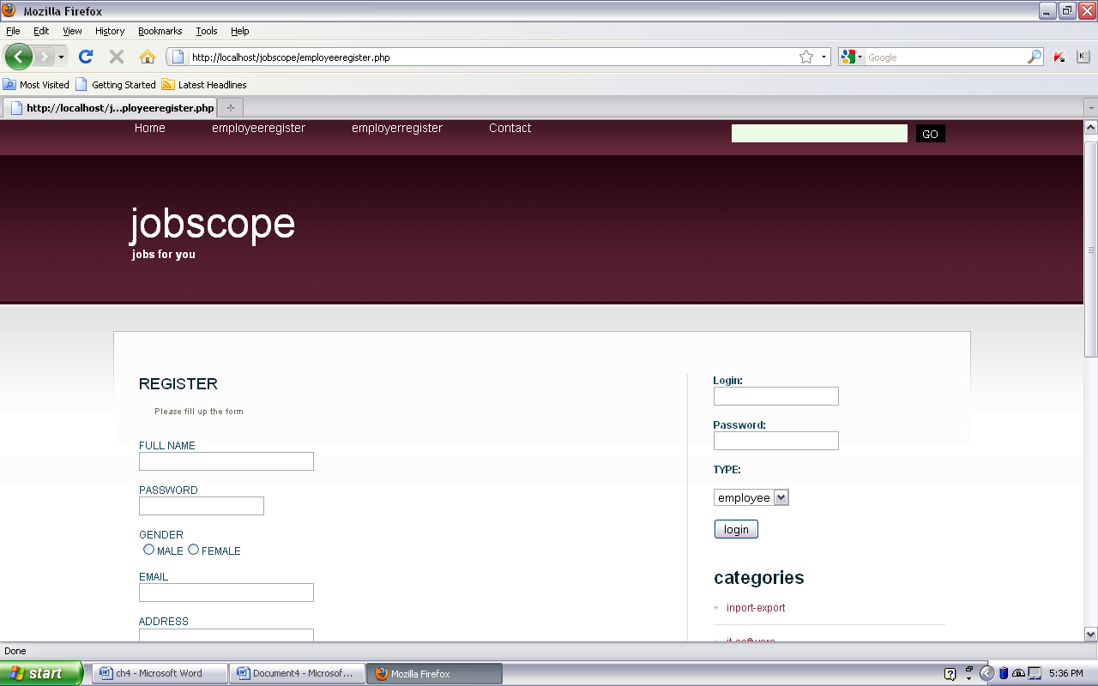

This is the employee registration form who want to login they should be fill this registration form. For registration insert query is used to store the data in employees table.

**4.3 EMPLOYER REGISTRATION PAGE**.

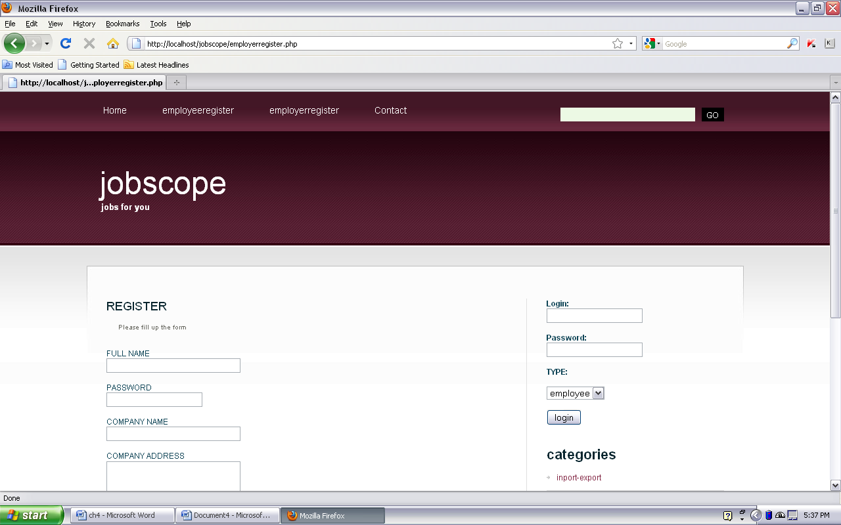

This is the employer registration form who want to login they should be fill this registration form. For registration insert query is used to store the data in employers table.

**4.4 CONTACT PAGE**

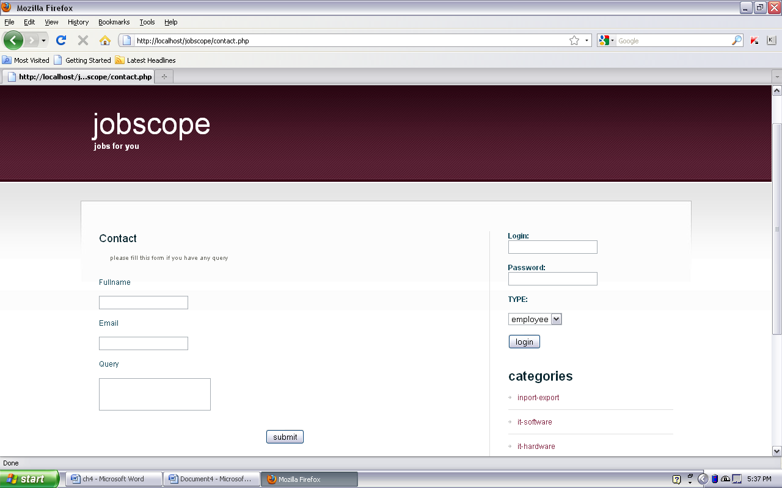

This is the contact page . if employer or employee have some query they can fill up this form. In this form insert query is used for store the data in contacts table.

**4.5 POST JOB PAGE**

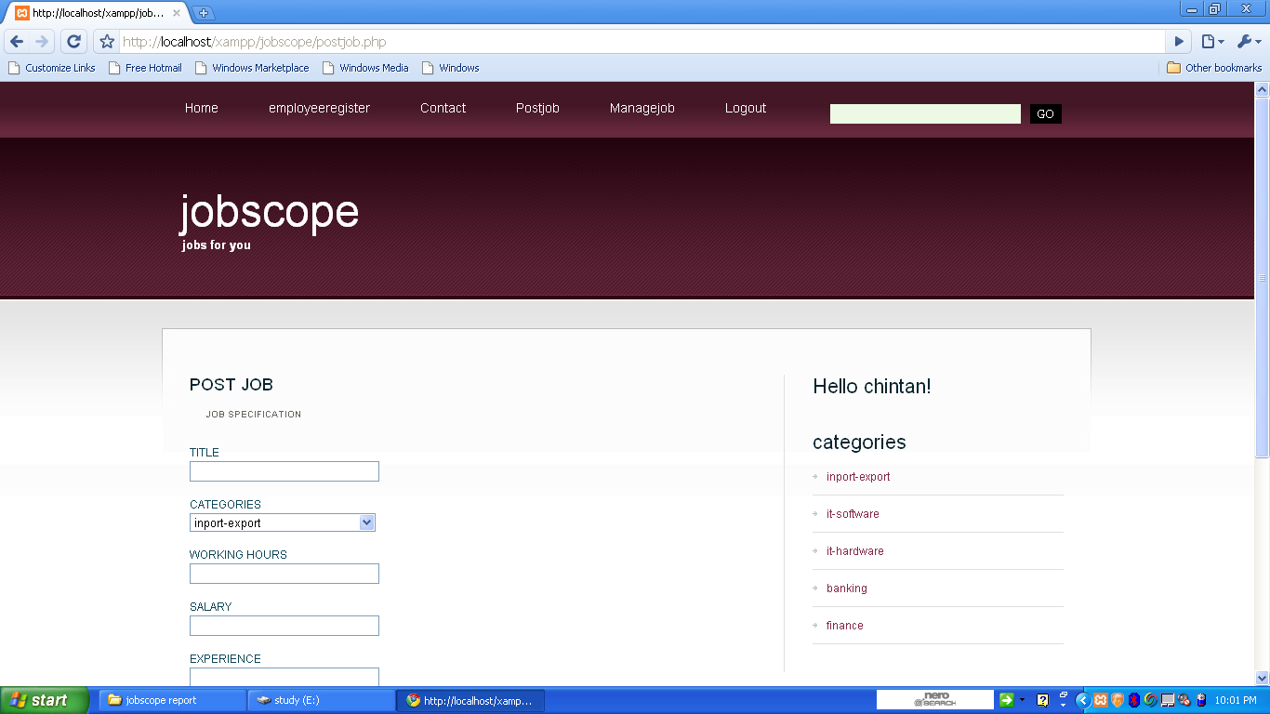

If the employer is login then he/she can post the job from this form .In this form insert query is used for data store in jobs table.

**4.6 MANAGE JOB PAGE**

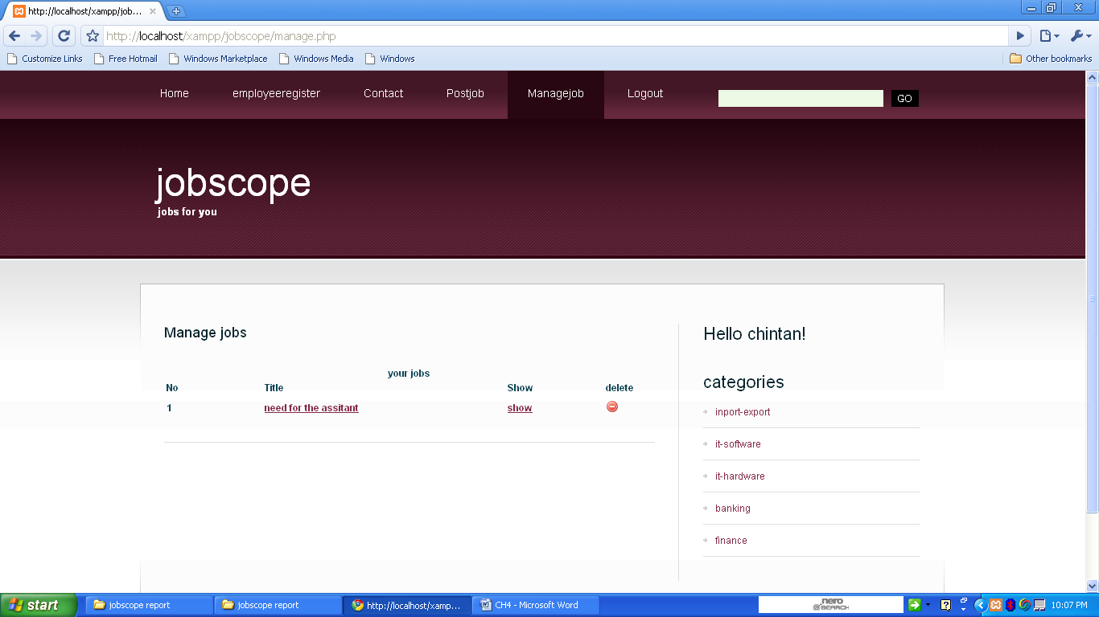

This is the manage jobs form. This form shows the list of vacant jobs listed by employer. In this form the delete query is used for delete the vacant job.

**4.7 JOB BY DEATIALS PAGE**

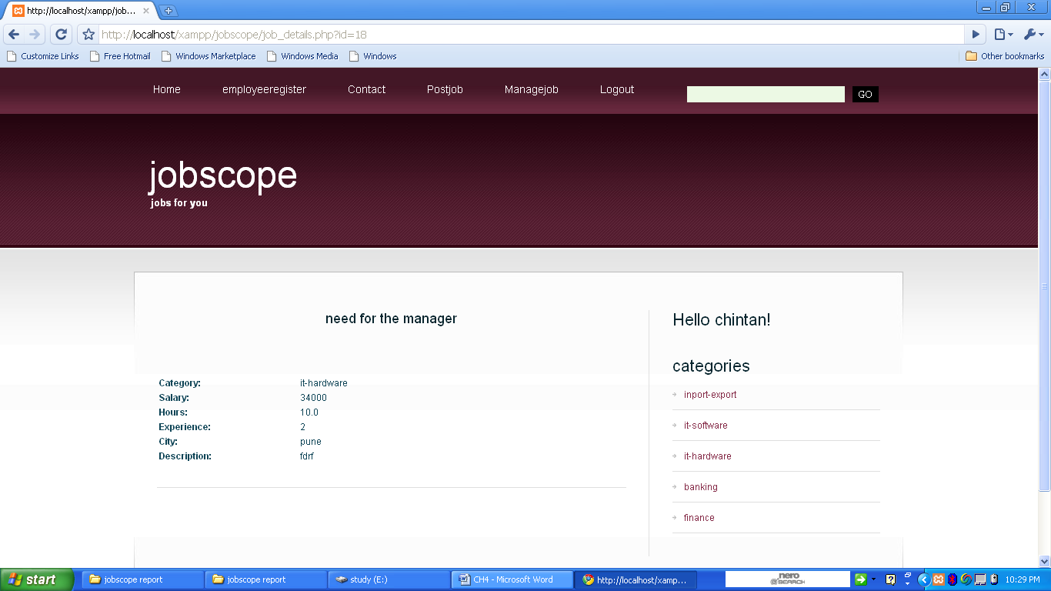

If the employee is login then he/she is apply for the job from this page.

**4.8 ADD/DELETE CATEGORIES PAGE**

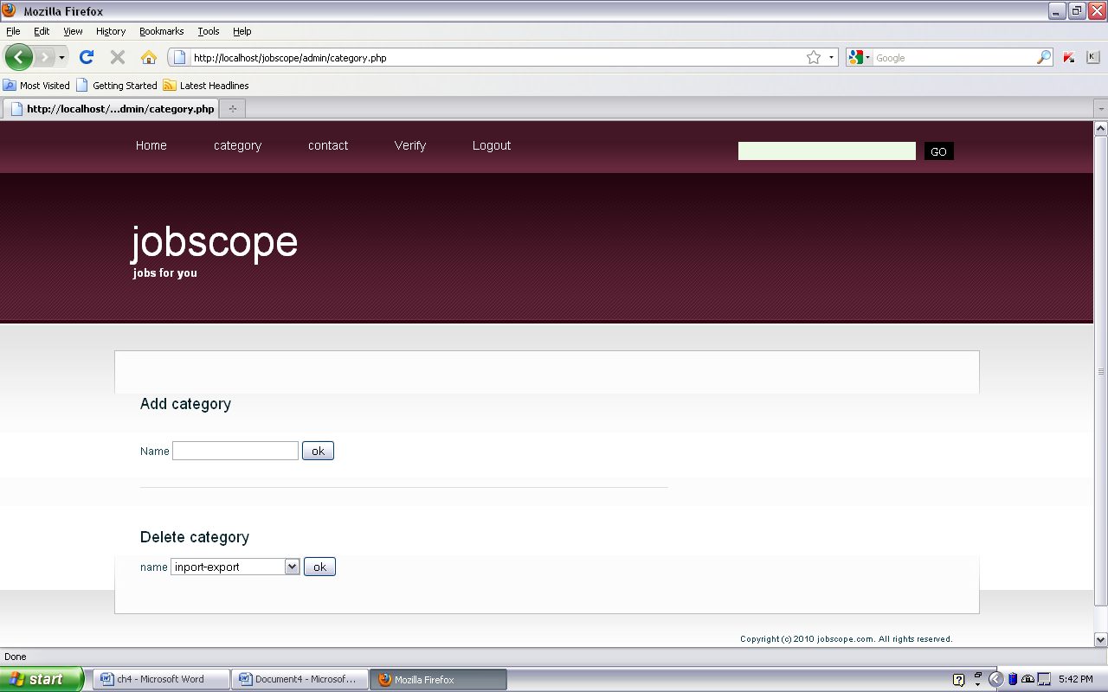

Admin can add/delete categories from this page. In this form insert and delete query is used.

**4.9 CONTACTS PAGE**

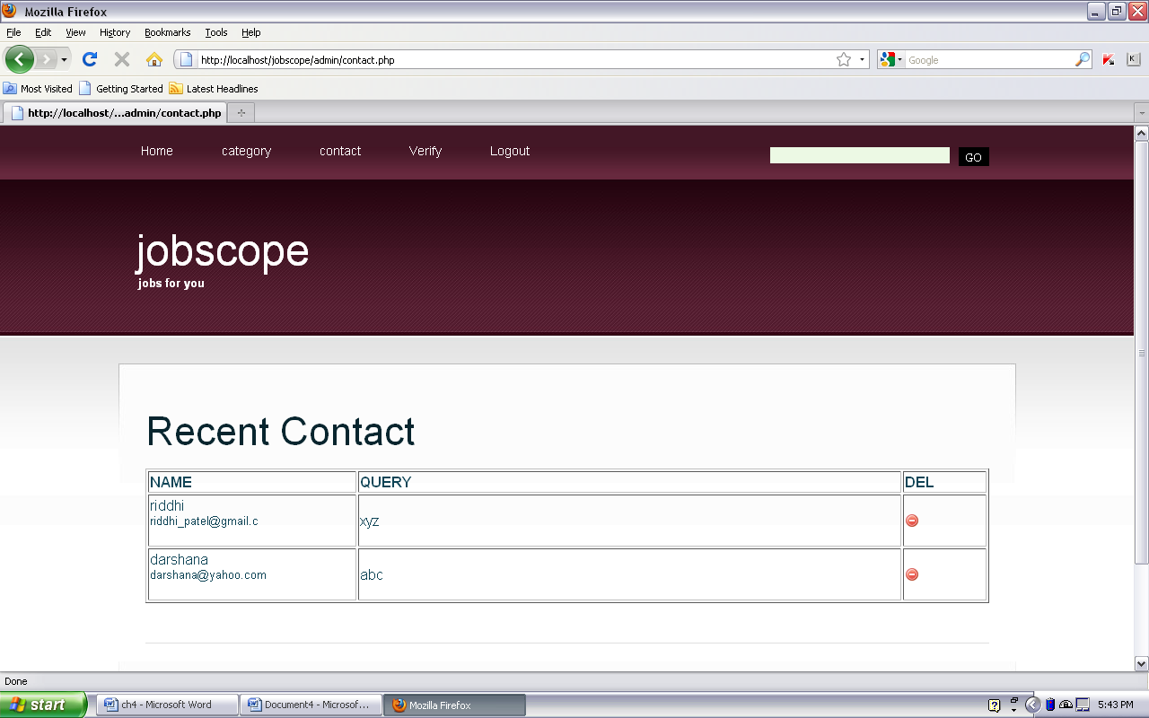

In this form admin can view and delete the query submitted by the employer and employee.

**4.10 VARIFY PAGE**

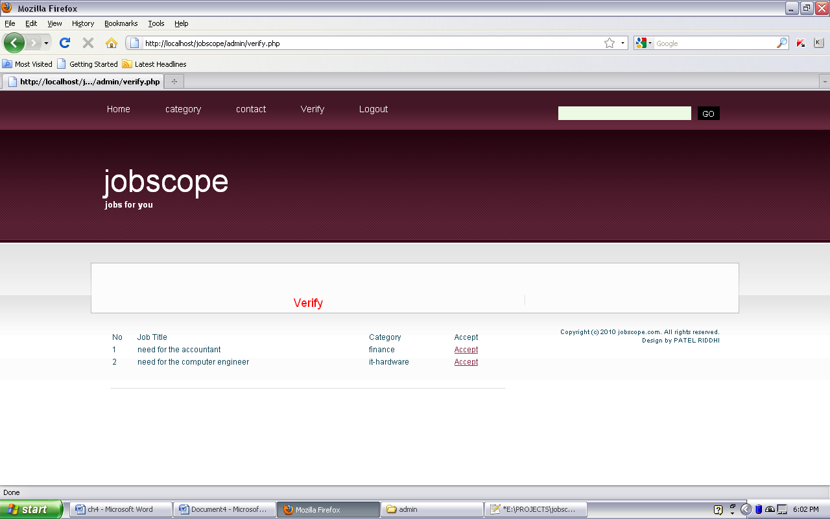

In this form admin can verify the jobs posted by the employer.

**5.ARCHITECTURE OF NEW SYSTEM**

**5.1 PACKAGE DIAGRAM**

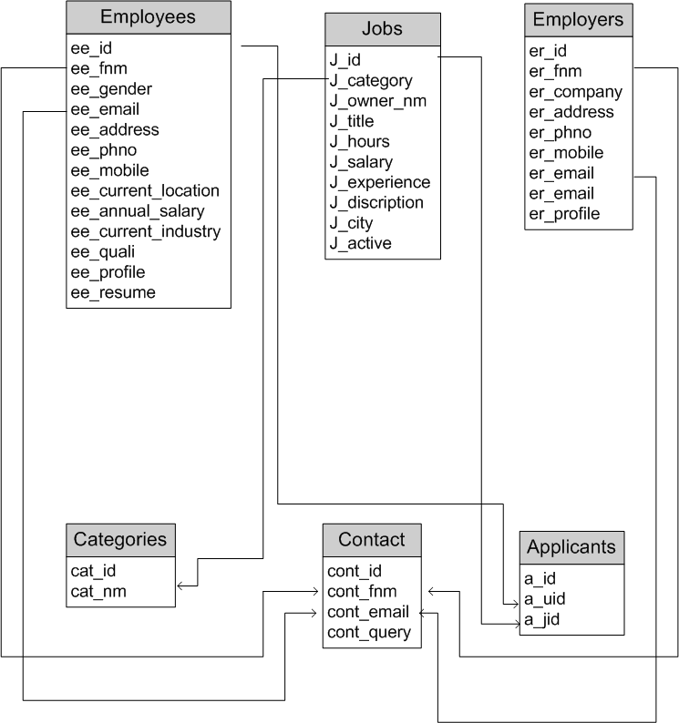

**Why testing is done**

* Testing is the process of running a system with the intention of finding errors.
* Testing enhances the integrity of a system by detecting deviations in design and errors in the system.
* Testing aims at detecting error-prone areas. This helps in the prevention of errors in a system.
* Testing also add value to the product by confirming to the user requirements.

**Causes of Errors**

The most common causes of errors in a software system are:

* **Communication gap between the developer and the business decision** **maker:** A communication gap between the developer and the business decision maker is normally due to subtle differences between them. The differences can be classified into five broad areas: Thought process, Background and Experience, Interest, Priorities, Language.
* **Time provided to a developer to complete the project:** A common source of errors in projects comes from time constraints in delivering a product. To keep to the schedule, features can be cut. To keep the features, the schedule can be slipped. Failing to adjust the feature set or schedule when problems are discovered can lead to rushed work and flawed systems.
* **Over Commitment by the developer:** High enthusiasm can lead to over commitment by the developer. In these situations, developers are usually unable to adhere to deadlines or quality due to lack of resources or required skills on

the team.

* **Insufficient testing and quality control:** Insufficient testing is also a major source of breakdown of e-commerce systems during operations, as testing must be done during all phases of development.
* **Inadequate requirements gathering:**  A short time to market results in developers starting work on the Web site development without truly understanding the business and technical requirements. Also, developers may create client-side scripts using language that may not work on some client browsers.
* **Keeping pace with the fast changing Technology:** New technologies are constantly introduced. There may not be adequate time to develop expertise in the new technologies. This is a problem for two reasons. First, the technology may not be properly implemented. Second, the technology may not integrate well with the existing environment.

**Testing Principles**

* To discover as yet undiscovered errors.
* All tests should be traceable to customer’s requirement.
* Tests should be planned long before the testing actually begins.
* Testing should begin “in the small” & progress towards “testing in the large”.
* Exhaustive Testing is not possible.
* To be most effective training should be conducted by an Independent Third Party

**Testing Objectives**

* Testing is a process of executing a program with the intent of finding errors.
* A good test case is one that has a high probability of finding an as yet undiscovered error.
* A successful test is one that uncovers an as yet undiscovered error.

**6.CONCLUSION**

* The working on the project “Jobscope” Was an extremely learning experience. We came across a no of new concepts and also enhanced our knowledge.
* Although we faced some problem during the designing and the implementation part but due to the moral support of our guide we were able to overcome the situation.
* In this project I completely enjoyed.
* The project has been completed as per the schedule

**ONLINE JOB PORTAL**



PREPARED BY:

GUIDED BY: